Insurance Claim Tracking System

# PHASE 6–10 IMPLEMENTATION (DETAILED)

## 6. User Interface (LWC)

Purpose:

The purpose of this phase was to design an interactive and user-friendly interface for agents, managers, and policyholders using Salesforce Lightning Web Components (LWC). This ensures that claim submissions, claim tracking, and managerial dashboards are intuitive, efficient, and aligned with Salesforce Lightning Design System (SLDS) standards.

Implementation:

1. Claim Submission LWC:  
 • Built a Lightning Web Component allowing policyholders or agents to submit claims.  
 • Used lightning-record-edit-form with input validation to ensure required fields were captured.  
 • Implemented client-side JavaScript validation for immediate feedback. 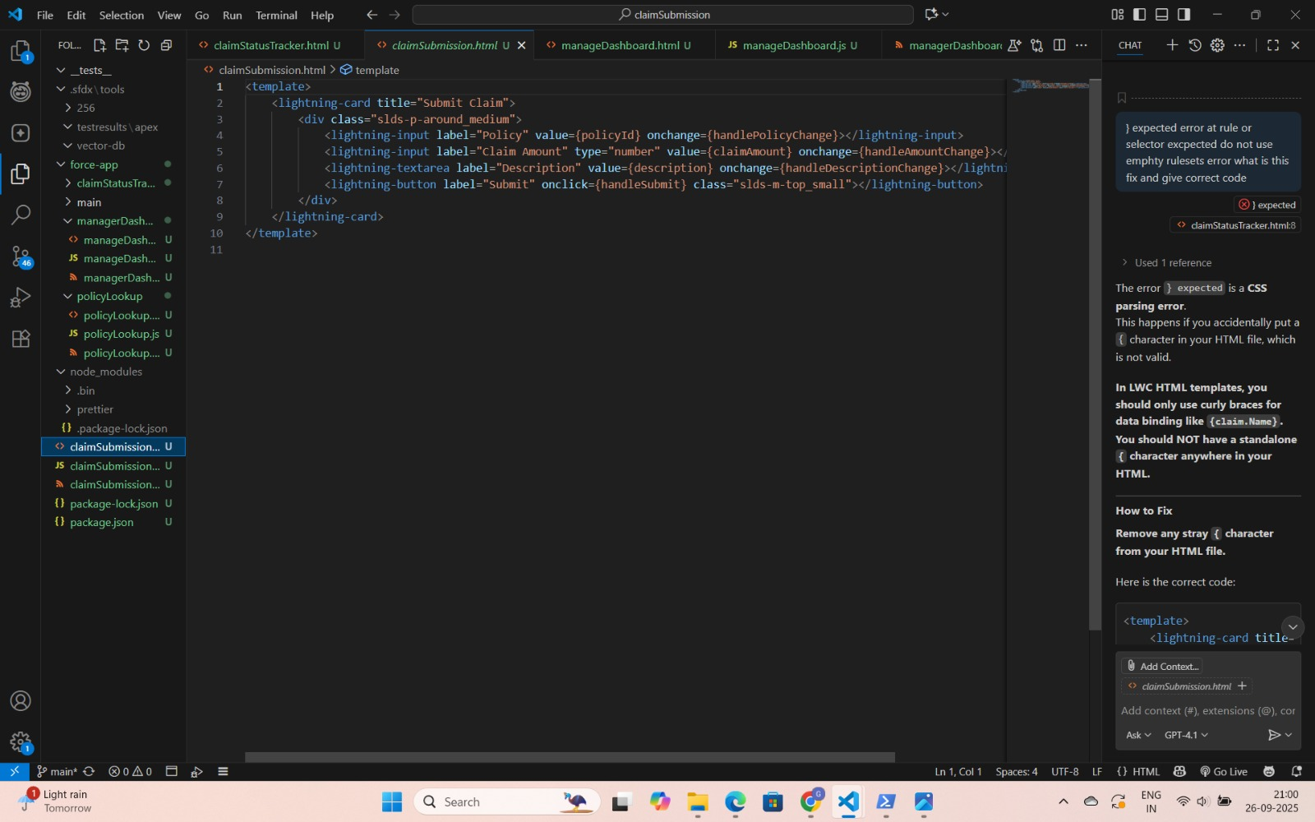

2. Claim Status Tracker LWC:  
 • Developed a component displaying claim progression using SLDS progress bar.  
 • Configured claim stages (Submitted → Under Review → Approved/Rejected).  
 • Integrated real-time updates with claim records. 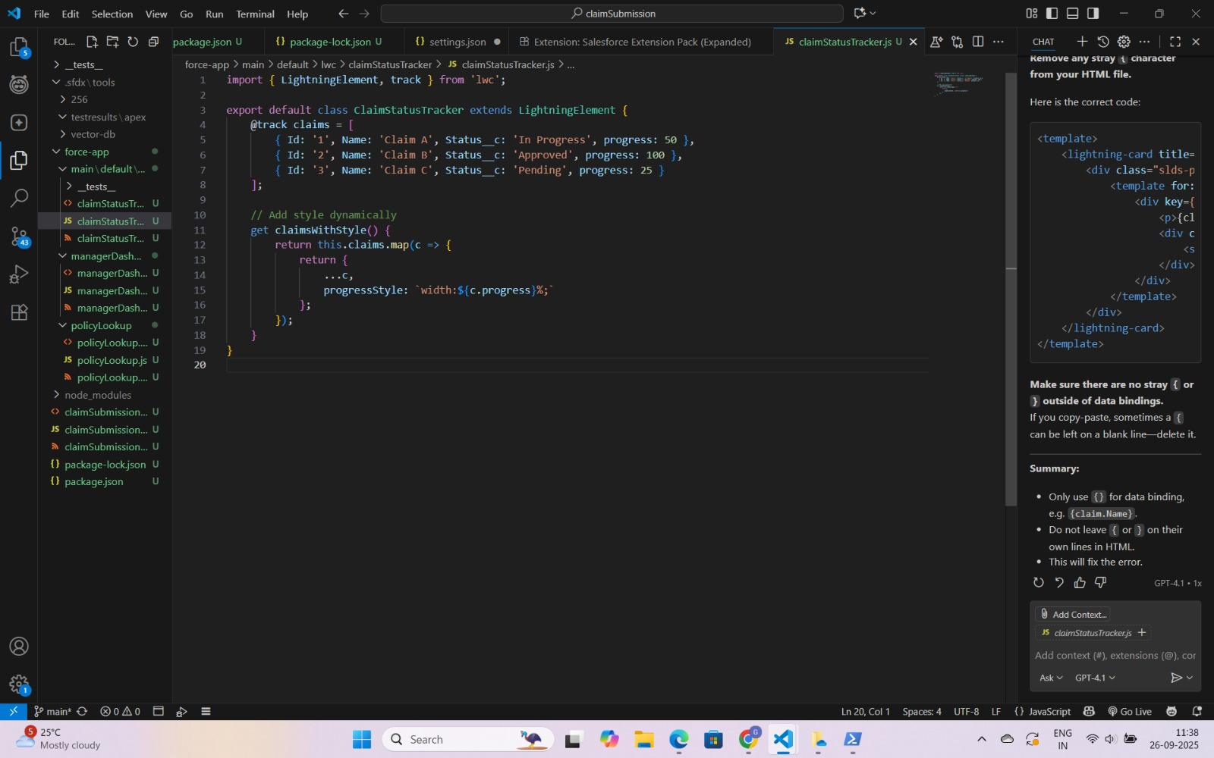

3. Manager Dashboard LWC:  
 • Created dashboard component that visualizes KPIs such as pending claims, approved claims, and high-value claims.  
 • Integrated charts (bar, pie) using Lightning Chart libraries. 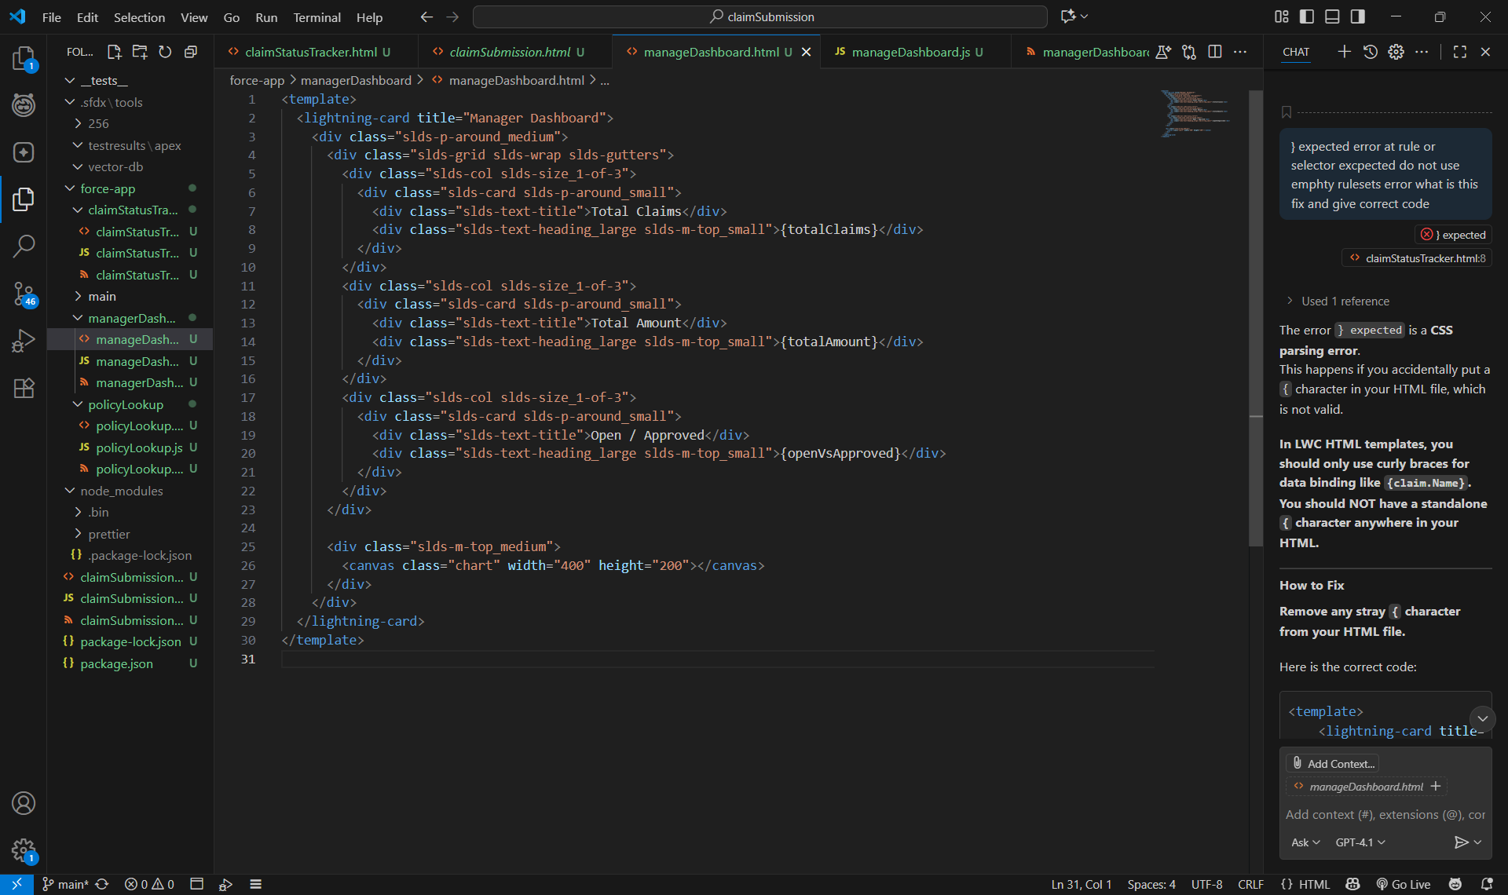

4. Styling and Responsiveness:  
 • Followed SLDS guidelines for consistent UI.  
 • Tested for responsiveness across desktop and mobile.

Business Impact:

The LWCs significantly enhanced usability, allowing agents to submit claims faster, policyholders to track claim status transparently, and managers to make data-driven decisions. The clean and responsive UI improved adoption and user satisfaction.

Testing/Verification:

Tested LWCs in Developer Org with multiple user profiles. Claims were successfully submitted, tracked, and displayed on dashboards with correct KPIs. UI rendered correctly across devices.

Completion Status: User interface implemented with fully functional LWCs and dashboards.

## 7. Integration & External Access

Purpose:

This phase aimed to connect Salesforce with external systems, such as a policyholder portal and third-party payment services, ensuring seamless data exchange and notification delivery.

Implementation:

1. REST API Setup:  
 • Exposed Claim Status data via REST API.  
 • Policyholder portal integrated with Salesforce to fetch claim information.  
  
2. Named Credentials:  
 • Configured Named Credentials for secure connection with third-party payment provider.  
 • Simplified authentication by storing credentials within Salesforce.  
  
3. Outbound Messages:  
 • Configured outbound messaging to notify external systems whenever a claim was approved.  
 • Ensured integration with external notification systems.

Business Impact:

The integrations improved customer experience by enabling policyholders to track claims directly from external portals. Payment processing was streamlined, and external systems were updated automatically, reducing manual intervention.

Testing/Verification:

Test API calls were made to verify claim status retrieval. Outbound messages were simulated to confirm successful transmission to third-party endpoints.

Completion Status: External integrations and REST APIs successfully deployed.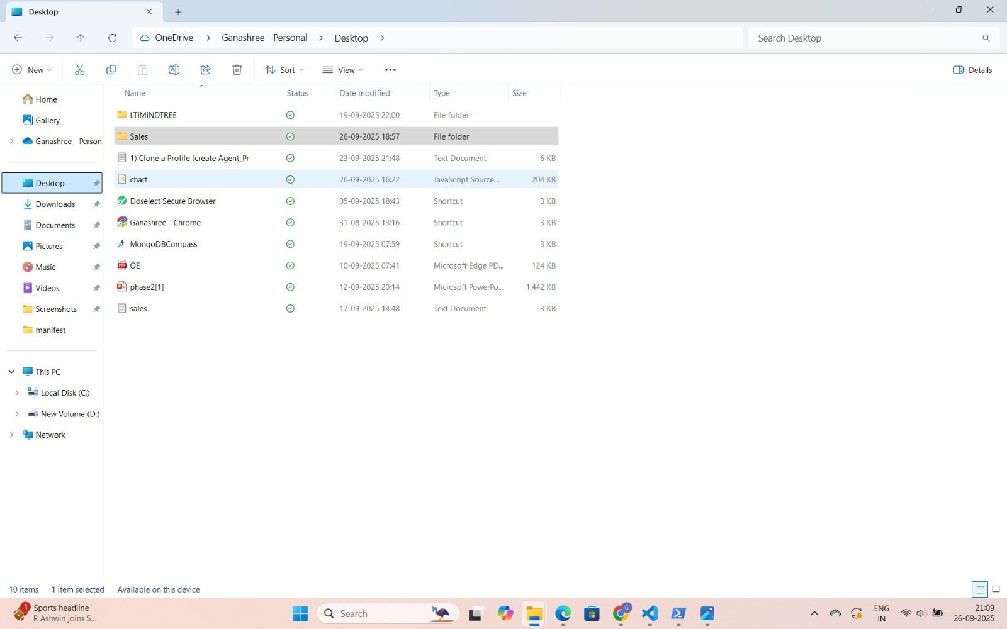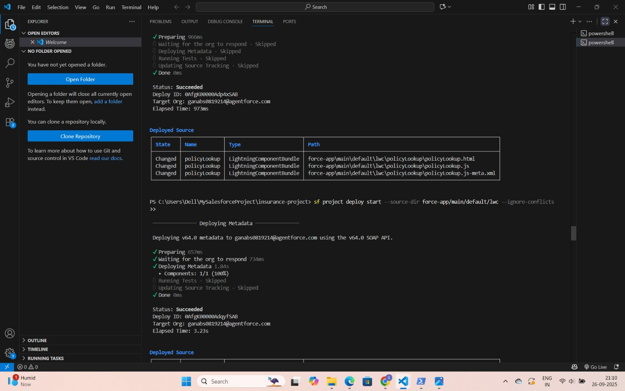

## 8. Data Management & Deployment

Purpose:

The purpose of this phase was to ensure accurate data migration, prevent duplication, and deploy the solution across different Salesforce environments securely.

Implementation:

1. Data Import:  
 • Used Salesforce Data Loader to import Policyholders, Policies, and Claims data.  
 • Validated mapping to ensure correct relationships were preserved.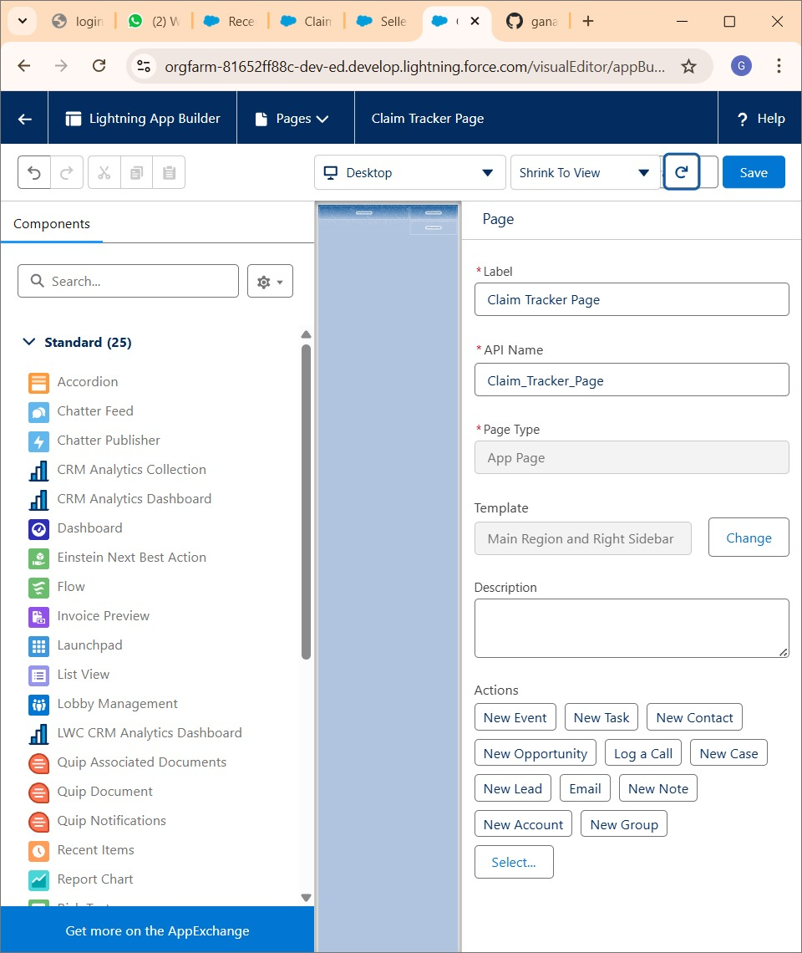  
  
2. Duplicate Management:  
 • Configured duplicate rules to prevent multiple records of the same policyholder.  
 • Alerts configured to notify users of potential duplicates.  
  
3. Deployment Strategy:  
 • Adopted a phased approach: Sandbox → UAT → Production.  
 • Used SFDX and Change Sets to move metadata between environments.  
  
4. Post-Deployment Checks:  
 • Verified data integrity in production.  
 • Conducted smoke tests to ensure core functionality was working.

Business Impact:

Data migration allowed existing records to be brought into the system seamlessly. Duplicate prevention improved data quality. The structured deployment strategy ensured minimal downtime and reduced risk of errors.

Testing/Verification:

Sample imports were tested in Sandbox before full migration. Duplicate detection was verified by creating test records with matching details. Post-deployment smoke testing confirmed stability.

Completion Status: Data successfully imported, duplicates prevented, and deployment completed.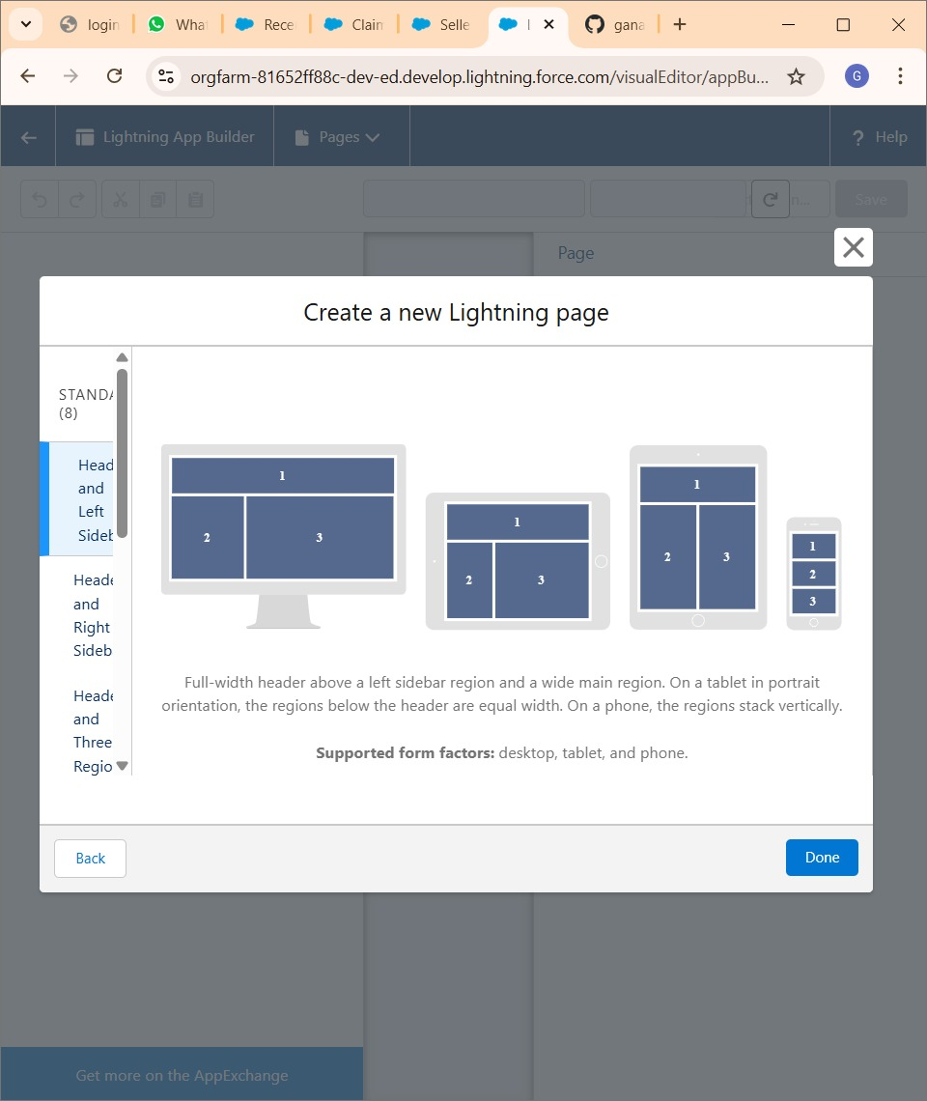

## 9. Reports & Dashboards

Purpose:

The goal of this phase was to provide managers and agents with actionable insights through Salesforce reports and dashboards, enabling better decision-making and performance tracking.

Implementation:

1. Reports:  
 • Claims by Status: Monitored claim lifecycle.  
 • Claims by Agent: Measured agent productivity.  
 • High-Value Claims Pending: Tracked high-risk claims requiring approvals.  
  
2. Dashboards:  
 • Manager Dashboard: Displayed KPIs for claim approvals and agent productivity.  
 • Agent Dashboard: Showed claims assigned to each agent.  
  
3. Security:  
 • Configured report visibility based on roles.  
 • Ensured compliance using OWD and FLS controls.

Business Impact:

Reports provided transparency across claim processes. Dashboards enabled managers to quickly assess performance and take corrective action where needed. This fostered accountability and improved operational efficiency.

Testing/Verification:

Reports were generated with test data to validate accuracy. Dashboards were reviewed with managers to ensure KPIs aligned with business goals.

Completion Status: Reports and dashboards successfully implemented and shared with stakeholders. 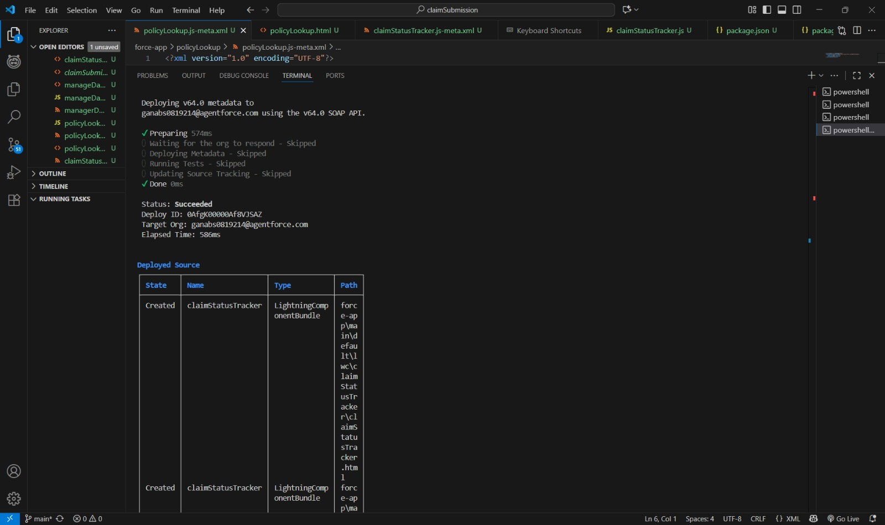

## 10. Demo & Handover

Purpose:

The final phase ensured smooth knowledge transfer to stakeholders through demos, documentation, and training. It prepared the project for production use.

Implementation:

1. Demo Flow:  
 • Simulated claim submission by an agent.  
 • Manager approval process demonstrated.  
 • Policyholder notification showcased.  
  
2. Showcase Reports & Dashboards:  
 • Highlighted Manager Dashboard and reporting features.  
  
3. Documentation & Video:  
 • Prepared detailed documentation with screenshots.  
 • Recorded demo video for future training.  
  
4. Handover:  
 • Delivered system documentation to Admins.  
 • Conducted Q&A sessions with end users.

Business Impact:

The demo and training ensured user readiness and confidence. Documentation provided a reference point for future enhancements. Managers and agents were equipped to use the system effectively from Day 1.

Testing/Verification:

Final end-to-end testing was performed during the demo. Stakeholders validated system functionality and approved project readiness.

Completion Status: Project successfully handed over with user training and documentation.